Chapter 14, Problem 71.

Use magnitude and frequency scaling on the circuit of Fig. 14.79 to obtain an equivalent circuit in which the inductor and capacitor have magnitude 1 H and 1C respectively.

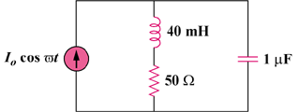

Figure 14.79
For Problems 14.39, 14.71, and 14.91.

